

Freeze Point Suppression Cycles:

A Platform Technology Whose Time Has Come

Rebound Technologies
January 2024

SUMMARY
In 2012 Rebound Technologies foresaw a significant opportunity to help avert climate catastrophe by disrupting the HVACR industry. Capitalizing on this, the Commerce City, Colorado company invented the Freeze Point Suppression (FPS) cycle; a new heat pump architecture capable of delivering higher efficiency, superior moisture management, enhanced operations, and lower costs to cold chain facility owner/operators. Rebound has commissioned the first full scale IcePoint unit at a cold chain facility in Greeley, CO.

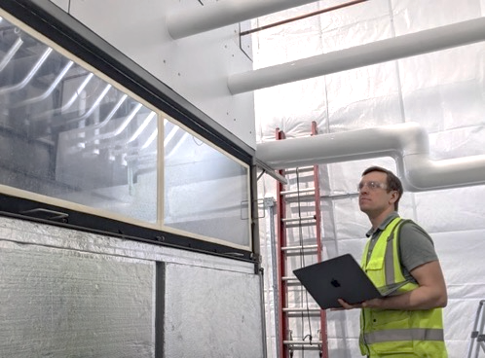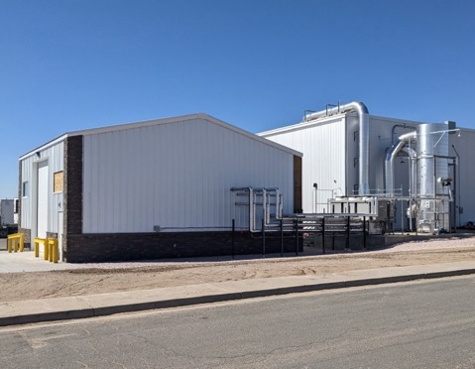
Figure 1: First full-scale industrial FPS cycle operating in Greeley CO in 2023.

ICEPOINT
Over the past 11 years Rebound's product IcePoint has shown proven results in various forms with Southern California Edison, Whole Foods, and Lineage Logistics. In 2022 Rebound demonstrated the moisture control and thermal agility benefits of FPS cycles during more than 2000 hours of factory acceptance testing of its commercial-scale equipment. Rebound is now in its third iteration of the full-scale equipment, preparing for volume manufacturing, and seeking investment for growth.

COMMERCIALIZATION
In early 2023, our first full-scale commercial FPS cycle was installed in Greeley Colorado at a 115,000 sq. ft. cold storage and blast freezing facility owned by Lineage Logistics. It provides up to 100kW of cooling capacity while simultaneously managing moisture levels throughout the facility and helping avoid peak energy rates.

During the 2023 testing period the FPS system hit all technical objectives and Lineage Logistics has signed a 5 unit LOI to begin rolling out IcePoint units throughout its portfolio of hundreds of facilities.

For more information, see Rebound’s Greeley Impact White Paper.

SCIENTISTS INDEPENDENTLY COROBORATE FPS CYCLES
In 2022, Dr. Ravi Prasher, CTO at Bloom Energy and Adjunct Professor at UC Berkeley, along with Drew Lilley, independently corroborated the FPS cycle’s potential with their own work on a pilot system they call the Ionocaloric Cycle, a sub-variant of the FPS cycle that focuses on ionic FPS materials and electro-membrane separation processes. Their paper, published in the American Association for the Advancement of Science (AAAS) confirmed that FPS cycles show significant thermodynamic advantages over existing technologies. Emmanuel Defray, in his introduction of the work in the same edition of the journal, goes so far as to say of FPS cycles:

“This is a serious contender for the future of cooling”
- Emmanuel Defray, Science Magazine, Dec 2022

In response to the work published in Science, FPS collaborator and Idaho National Lab Distinguished Staff Scientist, Aaron Wilson wrote in support of Rebound’s work:

"I am very glad to see this exciting science being highlighted. Rebound has been developing and advocating this new thermodynamic cycle for a long time and it’s great to see this potentially groundbreaking idea getting more attention."
- Aaron Wilson, Chemical Separations Group Lead, Idaho National Lab

The first patent for this cycle was issued to Rebound in 2016. Rebound has been granted 25 total patents covering the cycle, the cycle’s components, controls, and applications with many more in process.

Lilley and Prasher confirmed, in unequivocal terms, that the FPS architecture invented and patented by Rebound Technologies has fundamental advantages over vapor compression systems. Fortunately, we need not wait for a nascent FPS system to reach commercial readiness: Rebound is already at full industrial scale with a paying customer rolling out product.

MORE ABOUT THE FPS CYCLE ARCHITECTURE
Like a traditional vapor compression (VC) cycle, the FPS cycle moves a refrigerant through different processes and states to move heat from a low temperature to a high temperature. Where a VC cycle uses evaporation and condensation at different pressures, the FPS cycle uses melting and freezing at different chemical compositions. In both cases, a heat pump effect is produced; heat is removed from a cold environment and pumped to a higher temperature environment. For the FPS cycle, this is done in 4 steps (Figure 1):

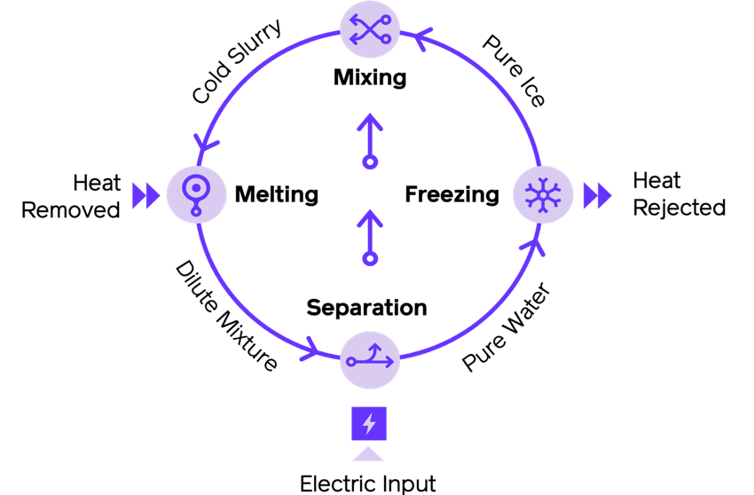
Figure 2: Thermodynamic states of the FPS cycle
- Freezing – pure refrigerant is frozen, dumping heat out of the cycle to ambient.
- Mixing – frozen refrigerant is mixed with a freeze point suppressant. The mixture spontaneously cools as the suppressant melts a portion of the ice.
- Cooling – Heat is absorbed at the low temperature by the melting ice.
- Separation – The refrigerant and suppressant are separated, creating the pure refrigerant and concentrated suppressant.

BENEFITS OF FPS
Since its inception in 2012, Rebound has been advocating that FPS cycles offer fundamental thermodynamic and first cost benefits over existing systems. Lilley and Prasher independently confirmed many of these benefits including significant entropic variation, large temperature lift potential, and high baseline efficiency values. While these properties have fueled the scientific development of the FPS cycle architecture, the benefits do not stop there.

SUPERIOR MOISTURE CONTROL
FPS cycles which use aqueous mixtures, like the IcePoint product, can directly capture humidity from low temperature air. Unlike traditional desiccant systems which remove moisture but add heat to conditioned spaces, FPS cycles simultaneously cool and dry air. This is accomplished by direct air-brine heat exchange. The air cools and dries as the brine warms and absorbs moisture. Figure 2 shows a typical arrangement of such a system.
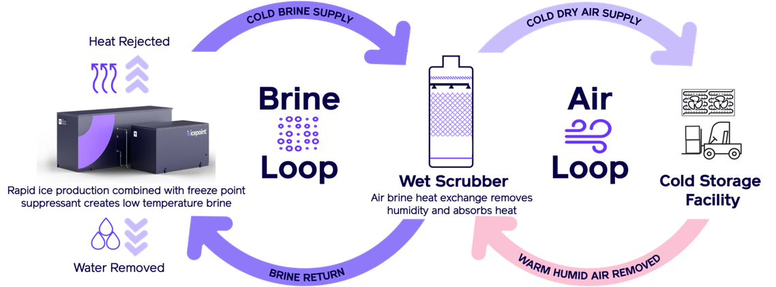

Figure 3: Typical FPS cooling and moisture control architecture

This arrangement leads to an ideal moisture level in the air without the need to over-dry, reheat, or post process the air, leading to the highest possible system efficiency. Additionally, the total equipment costs can be minimized because the desiccant regeneration and heat pump processes use the same equipment.

THERMAL AGILITY
Many FPS cycles, including the IcePoint system and the system studied by Lilley and Prasher, use readily storable refrigerants because they are ambient pressure liquids and solids. This means that the cooling provided by the cycle can be stored to minimize utility costs and improve facility operations. This benefit, which Rebound has named Thermal Agility, offers various improvements over incumbent tech:

- Agility can be used to avoid peak rates: For many industrial customers most of their utility costs are incurred during peak periods.

- Agility can be used to increase operational efficiency by removing thermal bottlenecks around product freezing (blast or continuous), washdown recovery, line outages, or logistical bottlenecks.

- Agility can be used to minimize first cost by reducing overall nameplate equipment size: vapor compression systems must be sized for the busiest hour on the hottest day and often run at only 50% utilization throughout the year. FPS cycle utilization in these scenarios is higher and capex is lower. This arrangement is similar to an electrical grid where variable loads are handled by agile generators (gas peakers for example) and base loads are handled by inflexible generators (coal for example).

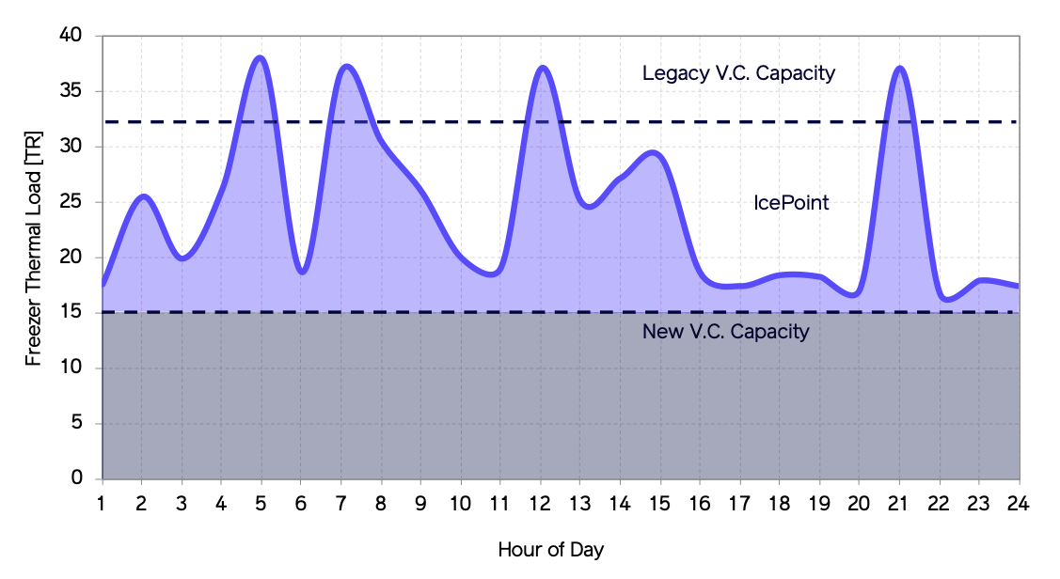

Figure 4: Example of real freezer loads in the 3PL space. VC + FPS (IcePoint) yields the lowest first costs because IcePoint is used for the load’s variable portion (purple) while VC provides the baseload (grey).

