

Low Temperature Frost and Moisture Control Via IcePoint

Rebound Technologies
April 2023
LOW TEMP MOISTURE: BIGGER REWARDS HARDER PROBLEMS
All air that is cooled by a heat pump has some small fraction of water vapor present within it. When that air is cooled enough water begins to condense out of the air. Desiccant systems, which remove moisture from the air instead of condensing it by cooling, are more common for higher temperature HVAC applications. However, the value of managing moisture is far greater at lower temperatures.

At low temperature conditions water vapor condenses out of air as solid frost which fouls coils unless they are regularly defrosted. For most large industrial processors, this equates to costly equipment downtime and increase labor rates. Removing this moisture without lost productivity would mean a blast freezer could freeze up to 5-10% more product using the exact same equipment and labor.

Furthermore, frost represents one of the most significant maintenance issues in a low temperature facility. Frost breaks doors, it clogs drains, it leads to flooding in frozen spaces, it causes accidents and injuries, it forms inside forklifts, and leads to more wear and tear on ammonia compressors, coils, and pumps. Removing moisture from air without forming frost leads to across the board savings for low temperature operators.

Unfortunately, despite the trove of benefits that can be realized by managing moisture in these conditions, there is no good solution out there.

SUPERIOR MOISTURE CONTROL
FPS cycles which use aqueous mixtures, like the IcePoint product, can directly capture humidity from low temperature air. Unlike traditional desiccant systems which remove moisture but add heat to conditioned spaces, FPS cycles simultaneously cool and dry air. This is accomplished by direct air-brine heat exchange. The air cools and dries as the brine warms and absorbs moisture. Figure 2 shows a typical arrangement of such a system.
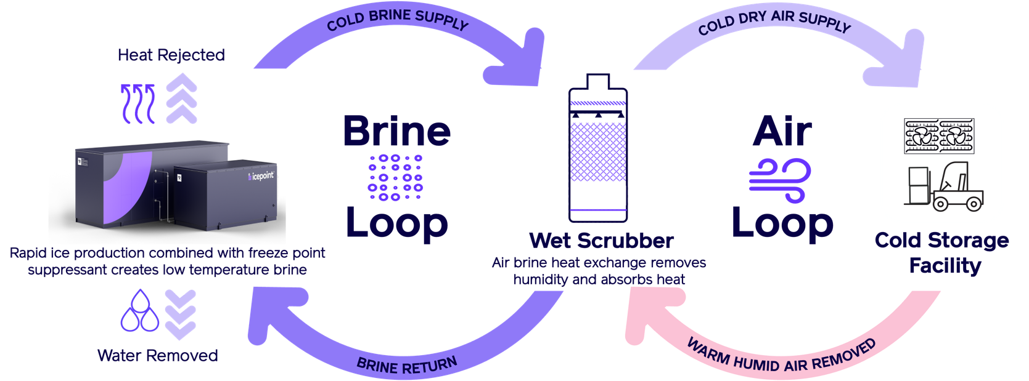

Figure 2: Typical FPS cooling and moisture control architecture

This arrangement leads to an ideal moisture level in the air without the need to over-dry, reheat, or post process the air, leading to the highest possible system efficiency. Additionally, the total equipment costs can be minimized because the desiccant regeneration and heat pump processes use the same equipment.

THERMAL AGILITY
Many FPS cycles, including the IcePoint system and the system studied by Lilley and Prasher, use readily storable refrigerants because they are ambient pressure liquids and solids. This means that the cooling provided by the cycle can be stored to minimize utility costs and improve facility operations. This benefit, which Rebound has named Thermal Agility, offers various improvements over incumbent tech:

- Agility can be used to avoid peak rates: For many industrial customers most of their utility costs are incurred during peak periods.

- Agility can be used to increase operational efficiency by removing thermal bottlenecks around product freezing (blast or continuous), washdown recovery, line outages, or logistical bottlenecks.

- Agility can be used to minimize first cost by reducing overall nameplate equipment size: vapor compression systems must be sized for the busiest hour on the hottest day and often run at only 50% utilization throughout the year. FPS cycle utilization in these scenarios is higher and capex is lower. This arrangement is similar to an electrical grid where variable loads are handled by agile generators (gas peakers for example) and base loads are handled by inflexible generators (coal for example).

Figure 3: Example of real freezer loads in the 3PL space. VC + FPS (IcePoint) yields the lowest first costs because IcePoint is used for the load’s variable portion (purple) while VC provides the baseload (grey).

COMMERCIAL REALITY
Lilley and Prasher independently confirmed, in unequivocal terms, that the FPS architecture invented and patented by Rebound Technologies has fundamental advantages over vapor compression systems. Fortunately, we need not wait for a nascent FPS system to reach commercial readiness; in 2022 Rebound demonstrated all these fundamental benefits, in addition to the more lucrative moisture control and agility benefits, during more than 2000 hours of factory acceptance testing of its commercial-scale IcePoint equipment. Rebound is now in its third iteration of the full scale equipment, preparing for volume manufacturing, and seeking investment for growth.

Starting spring 2023 the Greeley CO IcePoint installation will demonstrate:
- Facility-wide moisture management
- Improved product throughput capacity
- Demand response savings
- Freezer temperature fluctuation mitigation
- Maintenance cost reductions and decreased ammonia equipment burden
- Increased labor productivity
To learn more about Rebound Technologies, our FPS technology and IcePoint please visit www.rebound-tech.com.

