

Support for IcePoint’s Value Proposition: Implications of Initial Greeley Data

Rebound Technologies
November 2023
SUMMARY
Rebound’s first IcePoint system, shown in Figure 1, installed at the Lineage Logistics facility in Greeley CO was commissioned in April 2023. The unit is currently running, providing cooling and moisture control to the facility, and producing intermittent but promising data. Initial data, reported in June of 2023, unequivocally validated the fundamental thermodynamics and design of the IcePoint system. Since then, the system has provided more than 22MWh of cooling and absorbed more than 2000 gallons from the facility. More importantly, the data to date supports the value proposition Rebound has used to guide its development of IcePoint. Finally, the initial data indicates that Rebound’s next IcePoint system currently under development will be uniquely positioned to attack the blast freezer retrofit market with unparalleled value and efficacy.
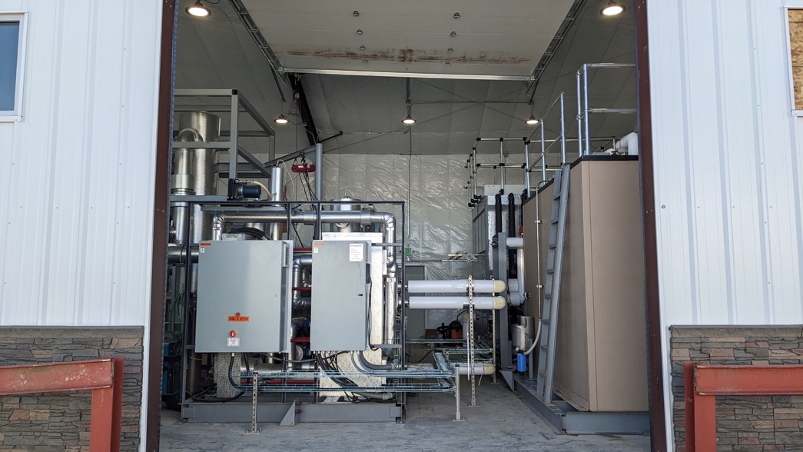
Figure 1: Initial IcePoint unit currently running in Greeley CO.
The data generated by the pilot thus far shows that the system is matching its modeled predictions and providing expected outputs. We have generated air temps below -10°F, removed 8 gallons per hour (GPH) of moisture, and provided cooling and dehumidification benefits while consuming no power for 5hr utilizing the system’s thermal storage. These performance metrics have been achieved because the heat pump is functioning as thermodynamically intended. This initial production release was designed to demonstrate the impact that the fundamental thermodynamics can have on a facility. With these impacts demonstrated, Rebound has now begun the iterative design of its next unit that will address several needed engineering improvements that were intentionally left out of the current design or not optimized due to timing and funding.
As the next unit design evolves based on Greeley performance data, that unit will be able to generate colder, dryer air. These improvements will allow the unit to more directly interact with the blast cells, leading to a simpler value proposition: 10,000 additional pallets of throughput per year. This dominates the value stack and is augmented by increased safety, lower labor costs, and energy savings.
Rebound has been developing IcePoint for 11 years. R&D is now complete and Rebound is transitioning to commercial product roll out: the next unit will not require any change in system capacity or scale. Instead, the improvements being rolled into the next unit are about access to high performance commercial compressors, integrating system level learnings from the current unit, and implementing more appropriate load-side heat transfer equipment.

CURRENT SYSTEM PERFORMANCE
The current system is meeting performance expectations. Table 1 shows the unit’s predicted values, the values achieved during the factory acceptance test, and the values achieved to date on site.
Table 1: Initial results vs modeled targets for Greeley Unit 1.
 | Modeled Target | Factory Acceptance Test (@ Rebound) | Initial Data (@ Greeley)
Compressor power [kWe] | 38 | 34 | 34
Ice maker thermal power [TR] | 33 | 38 | 36
Moisture absorption rate [GPH] | 7 | NA | 8
Cooling capacity [TR] | 24 | 24 | 19
Brine temperature [°F] | -22.0 | -21.6 | -18.4
Storage capacity [hr] | 3 | 3 | 5
Cycle COP | 1 | 0.97 | 0.79

To date, the system has provided 22MWh of cooling, created 1,200,000lb of ice and removed over 2000 gallons of water from the facility. Trailing 20-day availability as of November 14th was 54%.
Unequivocally, Rebound has demonstrated its ability to model, design, build, install, and commission a large piece of industrial equipment that delivers its intended value. Extrapolated to full impact, this thermodynamic operation has the potential of providing $480,000 of additional margin each year.
CURRENT GREELEY IMPACT
With the initial data that has been produced, a clear drying trend has been observed on the dock. Figure 2 shows two dock locations each of which shows a robust positive impact from Ice Point’s operation. A clear reduction in dew point temperature is shown that is present across multiple ambient conditions.

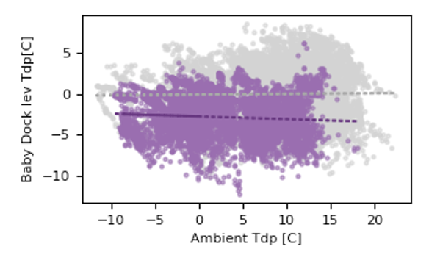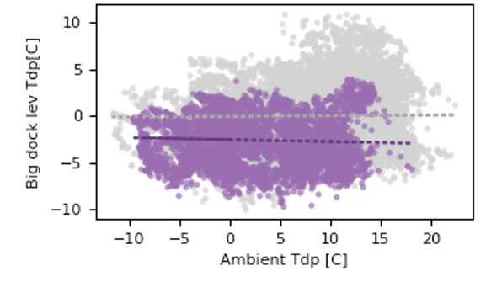
Figure 2: Impact of IcePoint (purple timepoints) on the dock at Greeley Co facility during May-November 2023. Grey dots represent baseline. Lower Tdp is better.
This impact was anticipated and represents a 30% drop in the dock’s relative humidity across the measured ambient temperature conditions. It shows the moisture is being removed from the facility commensurate to the moisture seen accumulated in the system.
THERMAL STORAGE CAPABILITY
In addition to validating the system’s thermodynamics and demonstrating moisture removal impact at the facility, Rebound has also used the Greeley facility to demonstrate IcePoint thermal storage capability. Despite only having a tank large enough to provide 3hrs of continuous storage, the Rebound team has demonstrated the flexibility of IcePoint’s thermal agility by ramping down cooling to provide value throughout and entire 5hr peak period event. Figure 2 shows an example of one such period where, despite consuming almost no power, the IcePoint system provides cooling and moisture control for >5hrs.
Figure 2: Demonstration of a 5-hour thermal energy storage period where cooling and moisture absorption is provided despite power consumption being reduced by >90%.
With this said, the goal of the project is to show the same impact in the freezer, and this has not yet been achieved. Given the units current level of performance, we would not expect to see this impact and a review of the data confirms this. To have a similar impact on the freezer, we must produce air that is dryer than the freezer and we must do that for long enough to overcome the equilibrium of moisture in the freezer already.
Greeley Freezer 1 (FR1), measured by 3 independent sensors, is very consistently at ~2-4°F and varies between 65% RH in the summer and 45% RH in the winter corresponding to a dewpoint temperature range of -4°F to -13°F for the summer and winter respectively. Given IcePoint’s stable brine activity, an RH of 75% is consistently produced at the wet scrubber outlet. Thus, to have a positive impact on the freezer, we must operate the system such that the brine temperature is below -10°F in the winter and 1°F in the summer. These values are the break-even points and to achieve quick impact, a lower brine temperature is required. Over the last 6 months Rebound has achieved significant system improvements toward this goal.
IMPROVEMENTS TO DATE
As discussed in our May 2023 summary, the system was commissioned in April 2023 and several integration issues were identified. These included: installation issues with the roof penetration that allowed significant liquid ingress into the facility and design issues with the wet scrubber that resulted in brine-air temperature pinches above spec. Furthermore, the May summary included a discussion of the importance of longer runtimes. Over the summer both these issues were addressed and, as we have proceeded through fall of 2023, runtimes have increased.
In august a roofer found significant faults in with the original roof penetration. These short comings were addressed by adding additional insulation to the curb and by re-sealing the curb with more appropriate materials. Figure 3 shows thermal imaging of the damper at similar ambient conditions with (left) no change, (middle) a damper installed, and finally (right) a reinsulated and sealed curb. These fixes have stopped the moisture ingress issue and resulted in a ice-free seal around the penetration.
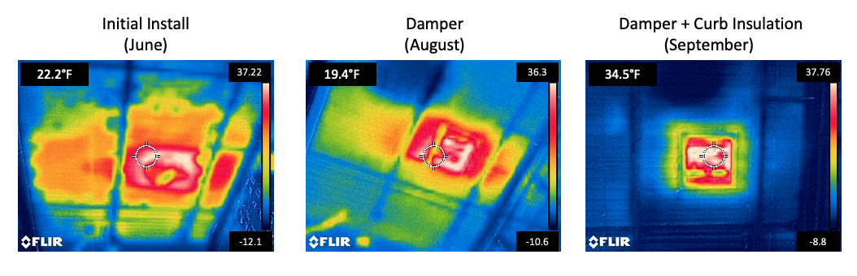
Figure 3: Improvement in roof penetration since original installation was completed.
Over the course of the summer Rebound removed the random packing in the wet scrubber and replaced it with a custom structure packing solution designed by AMACS corporation. This packing has 10X the surface area as the original packing and 50X the thermal conductivity. In addition, Rebound replaced the original brine distribution system supplied by the OEM with a better designed spray package designed in house. These two improvements resulted in a dramatic 10X improvement in the air-brine temperature pinch. Figure 4 shows the impact on pinch that this upgrade had.
Figure 4: Improvement in wet scrubber performance since original installation was completed.
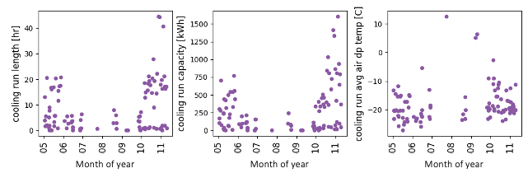
Finally, regarding longer runtimes, significant progress was made over the summer at increasing runtimes. Figure 5 shows the length, total delivered cooling, and average temperature of each cooling run the system has completed. A cooling run is defined as a uninterrupted delivery of cooling to the facility and can range from only a few minutes, to more than 40 hours. As can be seen in the length and capacity plots below, operation in October and November has shown a significant improvement in both length of run and capacity of cooling delivered since May. Cooling temperature, on the other hand, has gone up slightly as October and November saw significant VapoFan operation which results in a warmer brine temp.
Figure 5: Cooling run length, capacity, and delivered air temp since the system was commissioned.
This brine temperature limitation of the VapoFan has a significant influence on the potential impact the IcePoint unit can have. As Figure 6 shows, the potential impact has a non-lineage relationship with the total impact. Currently, at a brine temperature around -4°F our impact in limited. This is a function of the compressor used in the system and currently limited by a reliance on the VapoFan. However, Rebound has already demonstrated operation at Greeley using a higher compression ratio machine and that machine is currently underdevelopment.
Figure 6: Anticipated % impact as a function of the brine temperature generated by the system.

FUTURE IMPACT
As discussed above, the current Greeley system shows unequivocal validation of the IcePoint thermodynamic architecture. It also shows clear impact on the dock humidity and, with continued engineering improvements, will show similar impact on the freezer humidity. These impacts translate to higher facility throughput via lower frosting rates, fewer defrosts, and higher equipment utilizations.
The near-term value proposition of IcePoint is to target 10-20% gains in blasting throughput via retrofit integrations with an ROI of < 6 years. As we improve the integration, this will increase to 20-30% gains and paybacks in the 2-4 year range. This can be accomplished through a variety of different integration strategies with varying degrees of direct impact on the blast freezer.
Greeley #1 integrates by circulating air out of the dock, removing its heat and moisture, and placing it into the freezer. This creates positive pressure in the freezer that prevents air ingress, but more importantly, it allows IcePoint to actively remove moisture from the freezer (unlike dock-only moisture management). The most valuable aspect of the continued testing at Greeley is to understand this integration scheme’s impact on Greeley’s blast cells.
Currently, the product moisture, (predominantly moisture in cardboard) accounts for roughly 40% of the frost that forms in a blast cycle. The remaining 60% is thought to come from air ingress. A direct blast cell integration that processes 100% of the air in a blast cell could, in theory, prevent all this frost from forming on the coil and augment the coil’s power to increase throughput further. An integration that provides cold dry air directly to the blast cell might only capture a portion of the product moisture but all of the ingress. Finally, the current integration which only interacts with the freezer may capture only a portion of the 60% ingress value. This supports further investigations of optimized applications that balance IcePoint’s impact across blasting throughput, labor efficiency, utility costs, and equipment breakage.
Regardless of what integration scheme is used, the value potential is massive. Frost destroys the performance of a blast cell in 2 ways:
- Time spent in defrost: during defrost the refrigeration equipment, the cell itself, the facility infrastructure, and the facility’s operations and maintenance team, or poorly utilized. Blast cells spend anywhere from 6-15% of their time preparing for defrost, in defrost, or recovering from defrost.
- Frost inhibits airflow and lowers coil performance. As frost grows on a coil it blocks airflow and insulates the coil. A 50% coil blockage due to frost can yield a 90% reduction in airflow. At the same time frosts thermal conductivity is 20X lower than pure ice and near that of Styrofoam. Even the most frost resistant coil design still sees a total time-averaged 20% reduction in performance over the course of a blast due to frost.
Altogether, a blast cell successfully retrofitted to eliminate all frost could see up to a 44% increase in throughput.
Table 2: Required % of theoretical for 3 different throughput focused integration schemes for future IcePoint units.
 | Blast freezer only | Blast freezer via circulation | Freezer circulation
Pallets: IcePoint cooling | 18,000 | 9,000 | 1,000
Pallets: lack of defrost | 9,000 | 7,000 | 5,000
Pallets: increased coil capacity | 6,000 | 5,000 | 4,000
Total annual additional margin | $870,000 | $580,000 | $280,000
Labor, equipment, utility savings | $200,000 | $200,000 | $200,000
% theoretical for 6 year ROI | 20% | 30% | 50%
% theoretical for 4 year ROI | 35% | 50% | 80%
Payback at 100% of theoretical | 1.5 | 2.0 | 3.0

Table 2 shows the potential theoretical impact in both additional pallets and margin/savings as well as the percentage of these theoretical values that the equipment must achieve to reach a 6-year and 4-year payback. Also shown in this table in the “Labor, equipment, utility savings” row is the fact that, even in a blast focused install, significant savings are captured in the form of labor savings, reductions in equipment breakage, and utility savings that come from a dry environment. Finally, the theoretical payback for a system that achieves all its value is shown. Altogether, this analysis confirms the significant margin in the value prop and validates Rebound’s near-term scale-up strategy.
Beyond ROI: Over the next several installs, we will demonstrate the value of IcePoint not just at Greeley, but across different climates, products, operating environments, and facilities. Currently, IcePoint’s levelized cost is approximately $20,000/TR which is on-par with capacity retrofits on a 10s of tons of refrigeration scale when moisture management is considered. As IcePoint scales up to the 300-600TR range, its cost will dramatically drop making IcePoint-NH₃ hybrid systems the lowest first cost option for any facility. This would eliminate ROI concerns: IcePoint plus right sized vapor compression will be the lowest cost, highest value greenfield and retrofit solution for Lineage.
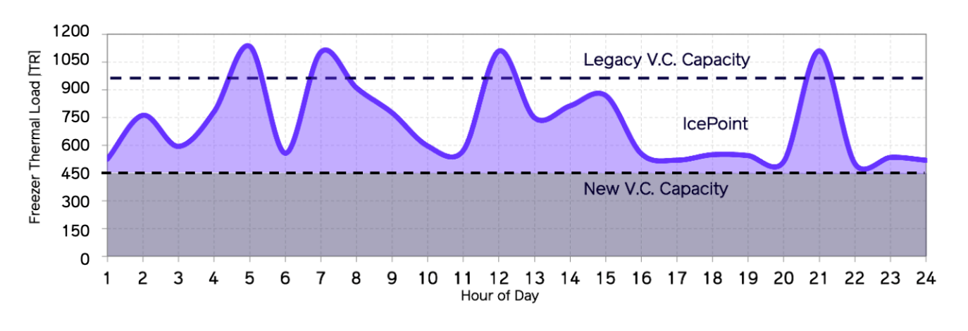
Figure 7: Example of a IcePoint - NH₃ hybrid system with a lowest first cost compared to pure NH3
Figure 4 shows a typical load for a freezer pick room in bold purple. To meet this load, a typical legacy NH₃ vapor compression (VC) system would need to be quite oversized (the highest dashed line). Still, this system would not meet the required load every hour of the day. In a hybrid IcePoint-NH3 system, the IcePoint unit handles the transient loads on the top of the curve while a smaller NH₃ system is able to run 100% of the time to meet the baseload requirement of the room.
This is a radically cheaper way to supply cooling to cold storage facilities. The IcePoint system is 2-3 fold smaller in nominal capacity, but the load is met more hours of the day. On top of this, the IcePoint system unlocks better NH₃ performance by keeping coils frost free and greatly reduces the stop/start cycles on the existing compressors. This combined solution does not require a payback calculation: it is the cheapest first cost and best performing solution on day one.
IcePoint offers significant value across the entire range of cold storage facilities and, more importantly, Rebound has a plan to scale. First, we begin with throughput-based retrofits. This allows us to ramp up production and improve product performance. From this beachhead we can scale into full facility hybrids and massive industrial rollout. Regardless of stage along this path, IcePoint’s focus is value, ROI, and optimized operational performance.

Based on 20wt% water cardboard throughout all pallets, the level at which cardboard spontaneously fails.
Based on Nsight data from Greeley and other Lineage facilities.
Based on measured Greeley conditions and analysis: https://www.osti.gov/biblio/20085619
Based on low airspeed 2.5fpn Frick coil.
Based on only improving Greeley’s south blast cells (288PPs). All models, assumptions, source material available upon request.
Based on a 1.5M fully installed cost, a value that is high enough for Rebound to operate as a profitable business.
This can be done by specifying that capacity with duplicate oversized frost-resistant coil systems (for simultaneous defrost) and a -40°F suction temp.

