

Falling Film Chillers - The Historical Context of IcePoint Ice Makers

Rebound Technologies
May 2025
STANDING ON THE SHOULDERS OF GIANTS
Rebound’s IcePoint® technology represents a breakthrough in how we make and use ice in HVAC and refrigeration applications. It’s self-healing surface chemistry enables a 10X improvement in ice production without the use of hot gas or mechanical harvesting, but it’s simple design and operation builds on a long history of similar equipment: the falling film chiller.

THE HISTORY OF FALLING FILM CHILLERS
The Falling Film Chiller, also known as a Baudelot cooler, has a history rooted in the 1850s with the invention of liquid coolers by Jean Louis Baudelot. Initially developed for the brewing industry to quickly and efficiently cool beer wort, it gained traction for its ability to rapidly cool large volumes while minimizing exposure to contaminants.
 | 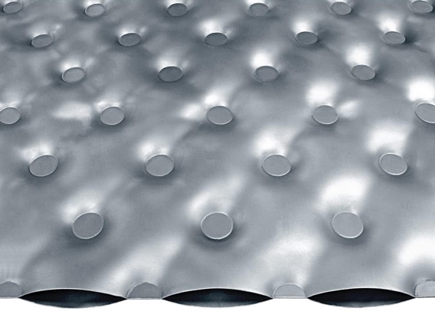

Figure 1: (left) a modern falling film chiller, (right) a cut-away example of a pillow plate heat exchanger.
Figure 1 shows a modern falling film chiller and an example of an expanded pillow plate heat exchanger. These pillow plate heat exchangers, which were developed in the 1960s, greatly improved the performance, footprint, and hygiene of falling film chillers.
Today, there are multiple manufacturers of falling films chillers, and thousands of facilities with operating falling film chillers. These systems are operating at extremely high reliability and, owing to their open designs, are easy to clean and service.
Key Falling Film Chiller Historical Developments:
1856: Jean Louis Baudelot patented a liquid cooler (Baudelot cooler), specifically for cooling beer wort in the brewing industry. This early design involved a fine copper sheet overlaying copper tubes, with cold water flowing countercurrent to the wort.
1916: Nusselt's work on liquid film flow patterns laid the foundation for heat transfer research on smooth vertical tube surfaces, though the theoretical model didn't fully capture real-world applications.
1960s: Multiple large heat exchanger manufacturers begin to experiments with pillow plate technology using multiple welding, forming, and inflating technologies as well as many unique plate geometries.
1970s: Large-scale experimental and mechanical investigations into falling film evaporation and heat transfer began, driven by the need to understand and improve industrial applications.
Modern Applications And Extensions Of The Technology:
- Falling film chillers
- Falling film evaporators
- Thermally (hot gas) harvested plate ice makers
Key Features Of Falling Film Chillers:
- Thin Film Cooling: A thin film of fluid is allowed to flow down over a heat exchange surface, promoting efficient heat transfer.
- High Cooling Rate: Falling film chillers achieve uniquely high advective heat transfer coefficients due to the thing nature of the films flowing down them.
- Constant Temperature: They maintain a consistent temperature of the chilled fluid, ensuring consistent product quality.
- Versatile Applications: They are suitable for a wide range of cooling needs, including food processing, chemical processes, and industrial applications.

REBOUND TAKES IT TO THE NEXT STEP
Combining the robust reliability of falling film chillers with the energy density and process impact of plate ice makers, Rebound uses advanced self-healing surface chemistry to transform falling film chillers into next-generation ice storage systems. Unlike plate ice makers that use inefficient, slow, and unreliable hot gas as a means to harvest, Rebound’s IcePoint technology uses subcooling and surface chemistry to harvest it ice in less than 30 seconds, a 20X improvement. This allows our ice maker to grow thin, efficient ice and, overall, see a 10X improvement in ice production for the same surface area.
More importantly, Rbeound’s IcePoint ice making technology achieves the steady refrigeration operation of an evaporative chiller, not the herky jerky on-off operation of a plate ice maker, leading to significantly longer compressor life. In a product like C1, which is built off the IcePoint ice-making technology, compressors turn on at the beginning of ice making and run at a single setpoint for 18 hours or more without changing suction setpoints, discharge conditions, or even operating speed in many cases. This leads to extremely long-life reliable refrigeration equipment.
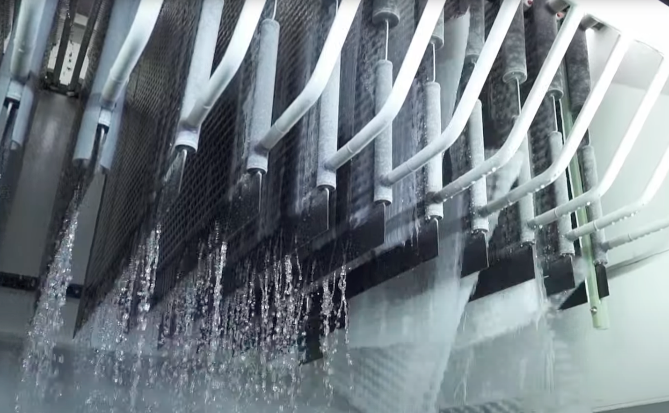
Figure 2: The IcePoint system I action. System controls are very similar to a falling film chiller, with harvest triggered by the curtailment of water flow.
When built into products like Rebound’s C1 thermal storage-equipped chiller or Rebound’s F1 low-temperature refrigeration cycle, IcePoint technology enables a 4-in-1 value:
- Agile cooling: decoupling power from time, these products can deliver cooling powers up to 150TR at a significantly lower first cost than competing chillers.
- Plug-and-play: both products are pre-fabricated and ready for power and fluid connections. No onsite engineering or assembly required.
- Moisture control: both products offer exceptionally efficient and effective moisture control in high-latent environments.
- Energy savings: All the energy savings, connected load reduction, incentives, and rebates of a battery in a non-flammable, non-toxic value-added package.

Interested?
CONTACT: Tom Armstrong
Tom.Armstrong@rebound-tech.com

