

LIZ: Revise IceCase to IcePoint

IceCase: The Most Cost Effective Ice Maker For Thermal Energy Storage Applications

Rebound Technologies
December 2023
For videos and more visit: www.rebound-tech.com/technology

SUMMARY
IceCase™ is a new breakthrough ice banking product set to disrupt cooling across the industrial and commercial sectors. IceCase uses a self-healing active surface chemistry to achieve a 5X improvement in cost/capacity, a 10X improvement in heat transfer, and a 2X improvement in efficiency.

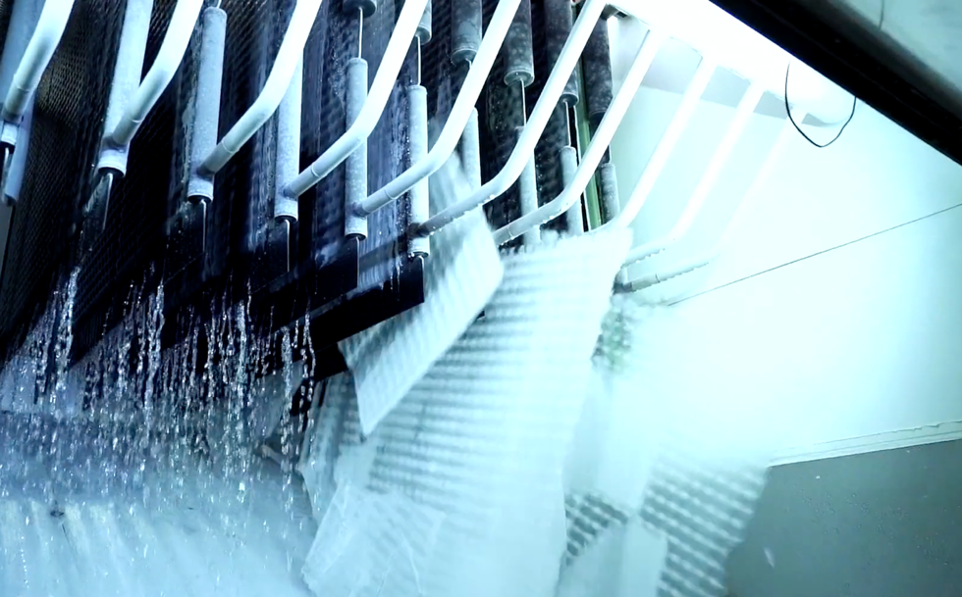
Figure 1: IceCase during its harvest phase. The ice maker is significantly more productive than the current state of the art.

ICE MAKER PHYSICS
All ice makers, regardless of design, function under a fundamental constraint: as ice grows on any surface it inherently inhibits heat transfer through that surface. This constraint drives the cost, efficiency, and reliability of all modern ice makers. Despite a great need for energy storage and the significant advantages ice storage enjoys, these tradeoffs have not yet been effectively optimized. This is evident in the universal failure or commercial stagnation in the market development of ice-based energy storage efforts,,,.

REBOUND’S APPROACH
Rebound has developed a novel approach to ice making that charts a new course through these constraints to realize a machine capable of producing higher quality ice at 5X lower costs than traditional approaches. Importantly, this ice maker uses 100% off the shelf process equipment and can be produced at scale without massive investment in new product development or new manufacturing processes.
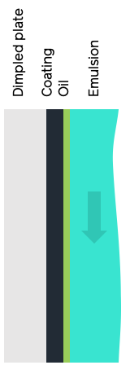 | 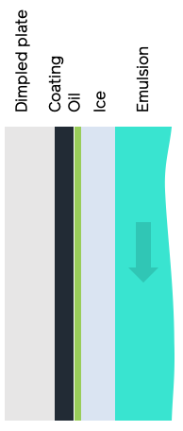 | 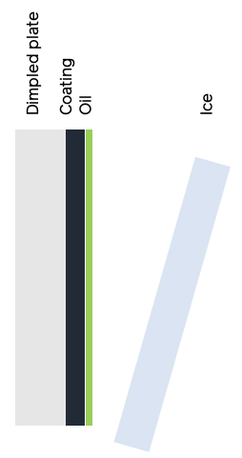
Step 1: Coating  An oil-water emulsion flows over a coated dimpled plate. The oleophilic coating draws oil out of the emulsion to form a self-healing submicron oil layer on the plate. | Step 2: Growth  Ice begins to grow on the plate trapping the oil between the ice and plate. Pure ice, free of oil, continues to form out of the emulsion. | Step 3: Harvest  The flow of emulsion is curtailed while refrigerant continues to cool the dimpled plate. The temperature drops, subcooling the ice and creating a thermal expansion driven strain between the ice and plate causing the ice to fall off.
Figure 2: the growth-harvest cycle of Rebound’s ice maker
Fundamentally, IceCase is a plate ice maker which goes through a typical growth harvest cycle: ice grows on the cold plate then is harvested when it reaches a desired thickness. However, unlike a traditional plate ice maker, IceCase harvests using subcooling instead of heating, which leads it to harvest significantly faster without any loses even when ice is grown in thin sheets. This is accomplished by paring a chemically matched plate coating and an oil dopant in the water that creates an ideal surface chemistry for ice making. Figure 2 shows the basic process.
By controlling surface chemistry with a thin liquid film (1um thickness) over a solid coating, a robust self-healing layer is created that dramatically improves the overall ice maker performance. This configuration leads to several key benefits of IceCase over the state of the art:
- Thinner ice can be grown and harvested without loss.
- Subcooled 100% solid ice is produced.
- Harvest is rapid, leading to a 90% reduction is wasted time.
- Plate temperatures are (relatively) high, leading to higher efficiency.
- No mechanical harvesting techniques are required, the only moving part that is used is a mag-drive water pump.
- Off-the-shelf dimpled plates mean the ice maker is infinitely scalable today.
The system is ideal for large energy storage applications because it is highly scalable. Like traditional plate ice makers that sit over a large water/ice tank, the plates can be arranged above an emulsion tank where the movement of the water by a centrifugal pump creates the emulsion required for the plates. In this configuration a single tank of water can be slowly converted to ice to store cooling for HVAC applications, turbine inlet cooling, or other industrial processes that require intermittent high levels of cooling. This system has one moving part, a mag-drive centrifugal water pump.

Rebound has built multiple full-scale units, generated millions of pounds of ice, and stored that ice for days at a time. This body of work has demonstrated several key performance and reliability features of this technology for use in thermal storage markets:
- 100% dry subcooled ice production at -5°C and -10°C refrigerant temperature
- Self-healing active coating with infinite life
- Greater than 12 hours of continuous operation without defrost or plate heating of any kind
- Rapid ice harvesting of <1min without ice loss
- Ice storage in a simple fiberglass tank without re-solidification or “iceberging” for 1-5 days
- Powder coating robustness through thermal cycles, incidental mechanical contact, and >10k ice harvests.

Table 1 shows the significant improvement IceCase represents over the state of the art. Of note, all these systems use nearly identical off-the-shelf components and manufacturing techniques. The only additional step required to manufacture an IceCase is the powder coating of the plates prior to the system assembly. This step is accomplished by a mature coating process performed by many coaters across North America and adds <5% to the cost of the ice maker.

Table 1: Comparison of Rebound’s ice maker with a traditional thermally harvested plate and ice-on-coil ice maker
 | Typical Ice-On-Coil System | Typical Plate Ice Maker | IceCase
Harvest method | direct flow | hot gas | subcooling
Ice Lost in harvest | 0% | 10-20% | 0%
Growth time [min] | multi-hour | >15 | 6
Harvest time [min] | multi-hour | 5 | 1
Ice Thickness [in] | >6in | >1/2” | <1/4”
Suction temp [°C/°F] | -30°C (-22°F) | -18°C (0°F) | -7°C (20°F)
Overall heat transfer [kW/m²-K] | 0.04 | 0.2 | 0.5
Levelized Capex [$/(lb/day)] | $50 | $20 | $5

CURRENT SCALE AND FUTURE MARKETS
Rebound has built multiple full scale production ice makers using this patented technology. The design is agnostic to refrigerant and Rebound has, to date, run these ice makers using R134a and ammonia as a refrigerant. As currently configured, Rebound’s largest ice maker (shown in Figure 6) can make 60,000lb of ice a day and has, to date, produced over 4,000,000lbs of ice. There are no design constraints that prevent scaling up to >1M lb/day capacity.

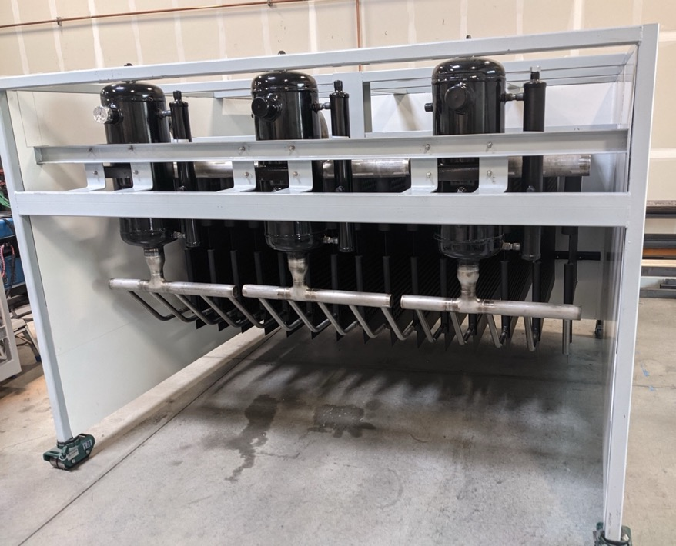
Figure 3: A 60,000lb/day ice making module ready for hookup to refrigerant feed.
IceCase is commercially ready for deployment in many thermal storage cooling applications. Covered by 2 issued and multiple pending patents, this technology is ready to scale up to meet the demands of large thermal energy storage markets like turbine inlet cooling, datacenter cooling, and HVAC ice banking. Where other ice making systems have failed to deliver the cost, efficiency, and scalability that is required in these markets, IceCase is unique in its simplicity and approach making accessing these markets a reality.

Ice energy files for bankruptcy: https://bit.ly/47XjfAV
BAC has moved away from their ice storage product: https://bit.ly/3v1UxAY
CALMAC sells to Trane after 70 years of tepid growth: https://bit.ly/3TtWDUm
Axiom Exergy Fails to commercialize ice storage and pivots to software only: https://bit.ly/3Ntkf7W

