

Agile Cooling

Rebound Technologies
September 2024
For more info visit: www.rebound-tech.com/technology

SUMMARY
IcePoint technology unlocks the use of ice across the entire HVAC spectrum as a storage material, a heat transfer medium, and a refrigerant. The core of IcePoint is an ice making technology that uses self-healing active surface chemistry to achieve a 5X improvement in cost/capacity, a 10X improvement in heat transfer, and a 2X improvement in efficiency. This breakthrough enables ice to be used in completely new and more valuable ways. We call this new value Agile Cooling.


Figure 1: C1 during its harvest phase. The ice maker is significantly more productive than the current state of the art.

ICE MAKER PHYSICS
All ice makers, regardless of design, function under a fundamental constraint: as ice grows on any surface it inherently inhibits heat transfer through that surface. This constraint drives the cost, efficiency, and reliability of all modern ice makers. Despite a great need for energy storage and the significant advantages ice storage enjoys, these tradeoffs have not yet been effectively optimized. This is evident in the universal failure or commercial stagnation in the market development of ice-based energy storage efforts,,,.

REBOUND’S APPROACH
Rebound has developed a novel approach to ice making that charts a new course through these constraints to realize a machine capable of producing higher quality ice at 10X higher productivity than traditional machines (ice production per hx surface area). Importantly, this ice maker uses 100% off the shelf process equipment and can be produced at scale without massive investment in new product development or new manufacturing processes.
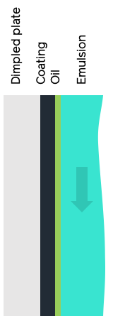 | 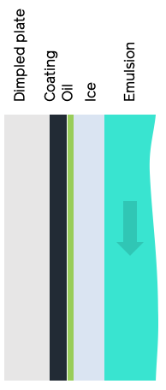 | 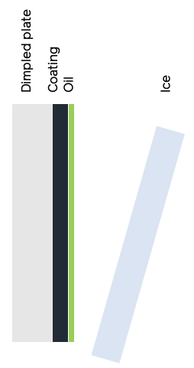
Step 1: Coating  An oil-water emulsion flows over a coated dimpled plate. The oleophilic coating draws oil out of the emulsion to form a self-healing submicron oil layer on the plate. | Step 2: Growth  Ice begins to grow on the plate trapping the oil between the ice and plate. Pure ice, free of oil, continues to form out of the emulsion. | Step 3: Harvest  The flow of emulsion is curtailed while refrigerant continues to cool the dimpled plate. The temperature drops, subcooling the ice and creating a thermal expansion driven strain between the ice and plate causing the ice to fall off.
Figure 2: the growth-harvest cycle of Rebound’s ice maker
Fundamentally, IcePoint based ice makers are plate ice makers which go through a typical growth harvest cycle: ice grows on the cold plate then is harvested when it reaches a desired thickness. However, unlike a traditional plate ice maker, IcePoint based ice makers harvest using subcooling instead of heating, which leads it to harvest significantly faster without any loses even when ice is grown in thin sheets. This is accomplished by paring a chemically matched plate coating and an oil dopant in the water that creates an ideal surface chemistry for ice making. Figure 2 shows the basic process.
By controlling surface chemistry with a thin liquid film (1um thickness) over a solid coating, a robust self-healing layer is created that dramatically improves the overall ice maker performance. This configuration leads to several key benefits over the state of the art:
- Thinner ice can be grown and harvested without loss.
- Subcooled 100% solid ice is produced.
- Harvest is rapid, leading to a 90% reduction is wasted time.
- Plate temperatures are (relatively) high, leading to higher efficiency.
- No mechanical harvesting techniques are required, the only moving part that is used is a mag-drive water pump.
- Off-the-shelf dimpled plates mean the ice maker is infinitely scalable today.
The system is ideal for large energy storage applications because it is highly scalable. Like traditional plate ice makers that sit over a large water/ice tank, the plates can be arranged above an emulsion tank where the movement of the water by a centrifugal pump creates the emulsion required for the plates. In this configuration a single tank of water can be slowly converted to ice to store cooling for HVAC applications, turbine inlet cooling, or other industrial processes that require intermittent high levels of cooling. This system has one moving part: a mag-drive centrifugal water pump.

Agile Cooling
Agile cooling represents the combined value of fully decoupling cooling generated from cooling delivered. In a standard cooling system the equipment must deliver the cooling it generates instantaneously. If the compressors generate more cooling than a facility requires, all that cooling is instantly delivered, the facility is over-cooled, and the compressors will turn off. Likewise, if a facility requires more cooling than the compressors are capable of the compressors will generate as much cooling as they can, deliver it to the facility, and the facility will warm up. The cooling generated and delivered are fully coupled and systems must be significantly oversized to make sure they can deliver the cooling when it is needed.
Other ice storage systems like plastic ice-on-coil technologies have achieved partial decoupling of cooling generated and cooling delivered. For example, a traditional ice bank can use compressors during times of lower load to build ice, then melt that ice when loads are higher. This operation is decoupled in time, meaning that the system can bank cooling and use it at some future time. However, owing to the nature of growing ice on a coil where the ice surface area is limited, the charging power will always be similar to the discharge cooling power. So, an ice-on-coil system might charge at 50TR for 10hr and be able to achieve a maximum of perhaps 70TR for 7hr of discharge cooling. For this reason, these system are still coupled in capacity.
IcePoint enabled systems, on the other hand, are decoupled in both time and capacity. Like ice-on-coil systems, IcePoint technology allows for cooling to be generated at one time and stored to be delivered at a time in the future. But unlike ice-on-coil systems, IcePoint enabled systems have none of the coil limitations around capacity and can easily scale to >>10X discharge powers than charge powers. So, while a product might charge its ice battery at 50TR for 10hrs, it might discharge at 500TR for 1hr. IcePoint enabled systems are the only ice storage systems that achieve total decoupling of cooling generation and delivery.
By decoupling generation and delivery of cooling, IcePoint enabled systems are able to deliver Agile Cooling which has significant value throughout the HVACR spectrum at both low and high temperatures. Below, four example applications are given to illustrate the unique value of Agile Cooling.

Comfort Cooling: A) ice is built slowly all day long except during peak hours from 15-18. B) Ice is used during the middle of the day to help right-sized chillers hit loads. C) during peak utility rate periods, ice is used to meet the entire load with a huge burst of cooling, slashing utility costs. | Food and Beverage: A) After the facility goes through washdown, it requires a phenomenal burst of cooling for a short time to recover. B) Ice can be used to help keep the processing floor within USDA spec.
Indoor Pools: A) At night, cooling loads are near zero and ice is banked. B) Cooling loads skyrocket during swim meets when occupancy reaches it’s max. C) even though loads are high, systems with agility can still avoid expensive peak rates. | Blast Freezing A) Every time a blast cycle stars, a large burst of cooling is delivered to speed the freezing process. B) Cooling can be limited or even completely turned off when the conventional system can handle the load, saving that cooling for the next peak.

Agile Cooling has universal value in the HVACR space. While every load is unique almost no load is constant and agility finds value in any volatility. Agile Cooling adds significant value in comfort cooling, agriculture, datacenters, remote crypto mining, food processing, cold chain, distribution, and more.

Ice energy files for bankruptcy: https://bit.ly/47XjfAV
BAC has moved away from their ice storage product: https://bit.ly/3v1UxAY
CALMAC sells to Trane after 70 years of tepid growth: https://bit.ly/3TtWDUm
Axiom Exergy Fails to commercialize ice storage and pivots to software only: https://bit.ly/3Ntkf7W

