Why Deeper Turbine Inlet Cooling Improves Performance and Economics
How Ice-Based Thermal Energy Storage Unlocks a More Efficient Cooling Regime
By Russell Goldfarbmuren, Founder and CTO at Rebound Technologies

Introduction
Gas turbines are highly sensitive to ambient conditions. As inlet air temperature rises, air density falls, reducing both power output and efficiency. For this reason, turbine inlet cooling (TIC) has long been used to recover lost performance during hot weather.
However, when operators evaluate ice-based thermal energy storage for turbine inlet cooling, one question appears consistently: Is it really optimal to cool turbine inlet air below 45°F?
At first glance, the answer seems unclear. Cooling air to lower temperatures generates additional condensate, and that condensation requires more cooling. From a thermodynamic standpoint, some of the cooling you apply to the inlet air is
“wasted” removing this additional moisture from the air, and because of this, the intuitive conclusion many people draw is that deeper cooling becomes inefficient.
The data shows the opposite.

The Psychrometric Question Behind Turbine Inlet Cooling
When humid air is cooled, two processes occur simultaneously:
• Sensible cooling – lowering the temperature
• Latent cooling – removing moisture through condensation
Condensation consumes cooling capacity, which creates the perception that deeper cooling wastes energy. In practice, however, when the physics of moist air meet the physics of the gas turbine, going to colder temperatures is almost always the right thing to do.
To understand why, we can examine the thermodynamic behavior of turbine inlet cooling across a range of cooling depths—particularly the deeper temperature ranges enabled by ice-based thermal energy storage systems.

All plots in this analysis assume the same starting condition: Ambient air at 80°F and 89% relative humidity.
The horizontal axis in each plot represents degrees of cooling from that ambient condition. For example:
• 10°F cooling results in turbine inlet air at 70°F and 100% relative humidity
• 35°F cooling results in turbine inlet air at 45°F and 100% relative humidity
Traditional chilled-water cooling systems typically operate around 20 degrees of cooling, while ice-based systems can operate much further, achieving deeper inlet temperatures.

Cooling Depth vs. Turbine Power Output
The first plot compares three quantities:
• Cooling required (thermal kW)
• Turbine electrical output increase due to efficiency improvements
• Total turbine electrical boost including additional fuel burn
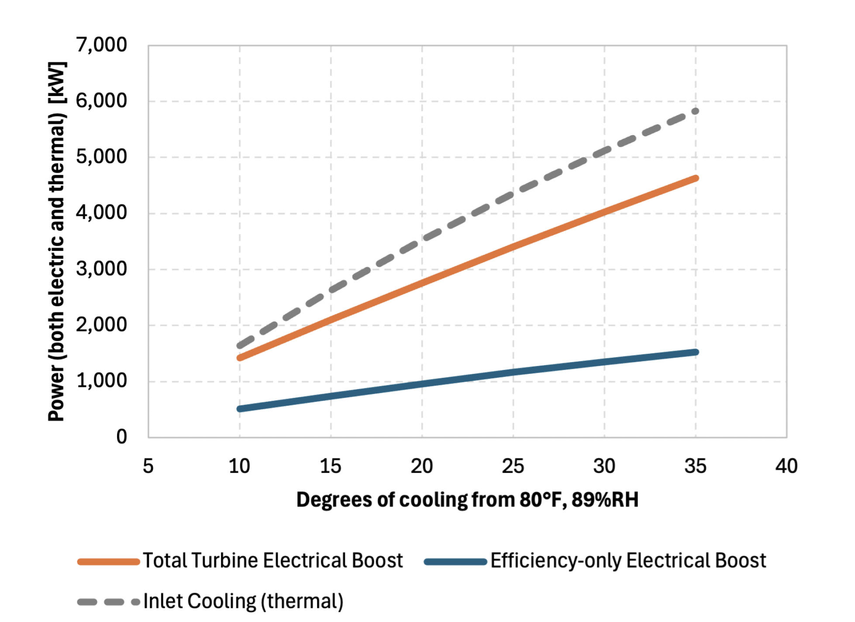
The results are straightforward. As cooling increases (grey dashed), turbine output rises steadily. Deeper cooling increases air density entering the compressor, allowing the turbine to produce more power.
The chart shows that the total (orange) boosted power is higher because when you cool the inlet of a turbine, you make it more efficient (blue) AND can consume more fuel.
In other words, deeper cooling directly translates into higher electrical output.

Condensate Generation and Latent Cooling
The second plot examines condensate formation.
As expected, the amount of condensate increases as the air is cooled further. Because the starting point is so moist, condensate forms even at a small amount of cooling. However, the rate of increase slows as temperatures drop. This occurs because colder air can hold less moisture.
The chart also shows the latent heat ratio (LHR), which represents the fraction of cooling devoted to moisture removal.
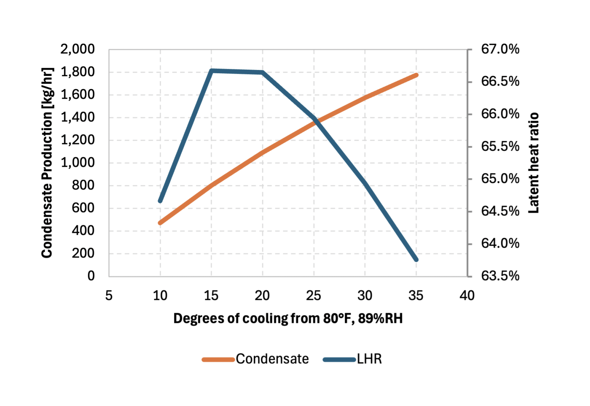
Initially, the latent heat ratio increases as cooling begins. However, beyond moderate cooling depths, the trend reverses. The system transitions back toward more sensible cooling relative to latent cooling.
This shift becomes important in evaluating system performance.

The Hidden Problem with Moderate Cooling
The third plot reveals one of the most interesting results in the analysis.
Round-trip efficiency (orange) decreases as deeper cooling is applied. On the surface, this may appear to support the idea that deeper cooling is less efficient.
But when turbine output is included in the calculation, the picture changes.
The coefficient of performance (COP) reaches a minimum at moderate cooling levels and then begins to improve again as deeper cooling is applied.
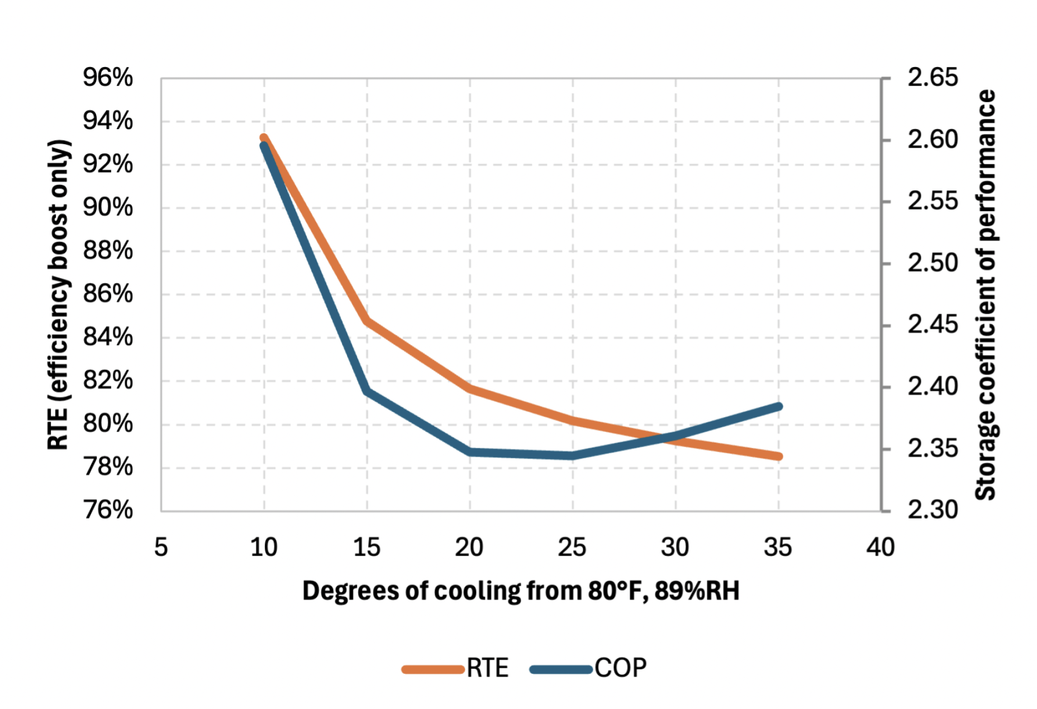
This result highlights a critical point: moderate cooling levels are often the least efficient operating point.
At these temperatures, the system spends a disproportionate amount of cooling capacity on moisture removal while not fully realizing the turbine performance gains associated with deeper cooling.
Chilled-water systems often operate precisely in this middle range.
Ice-based systems can push past this region and access the more favorable performance regime.

Economic Implications for Generation Assets
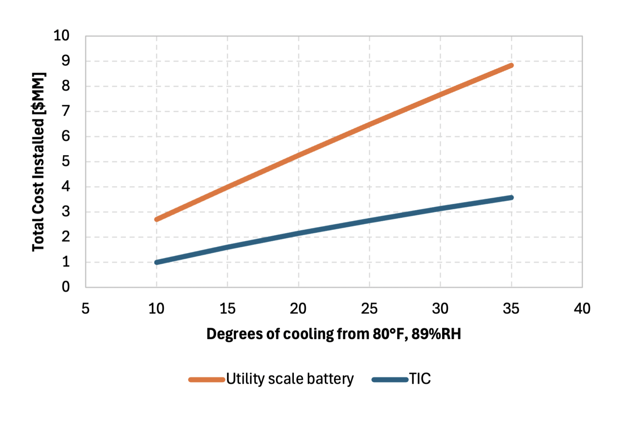
Performance improvements alone do not determine whether turbine inlet cooling makes sense. Economics ultimately drive deployment decisions.
Installed TIC systems can provide comparable peak capacity augmentation at significantly lower capital cost than battery storage for similar output levels.,
For generation operators seeking peak capacity solutions, turbine inlet cooling can provide a cost-effective alternative to traditional grid-scale storage options.

Operational Takeaway
For turbine operators evaluating inlet cooling technologies, the physics lead to a clear conclusion.
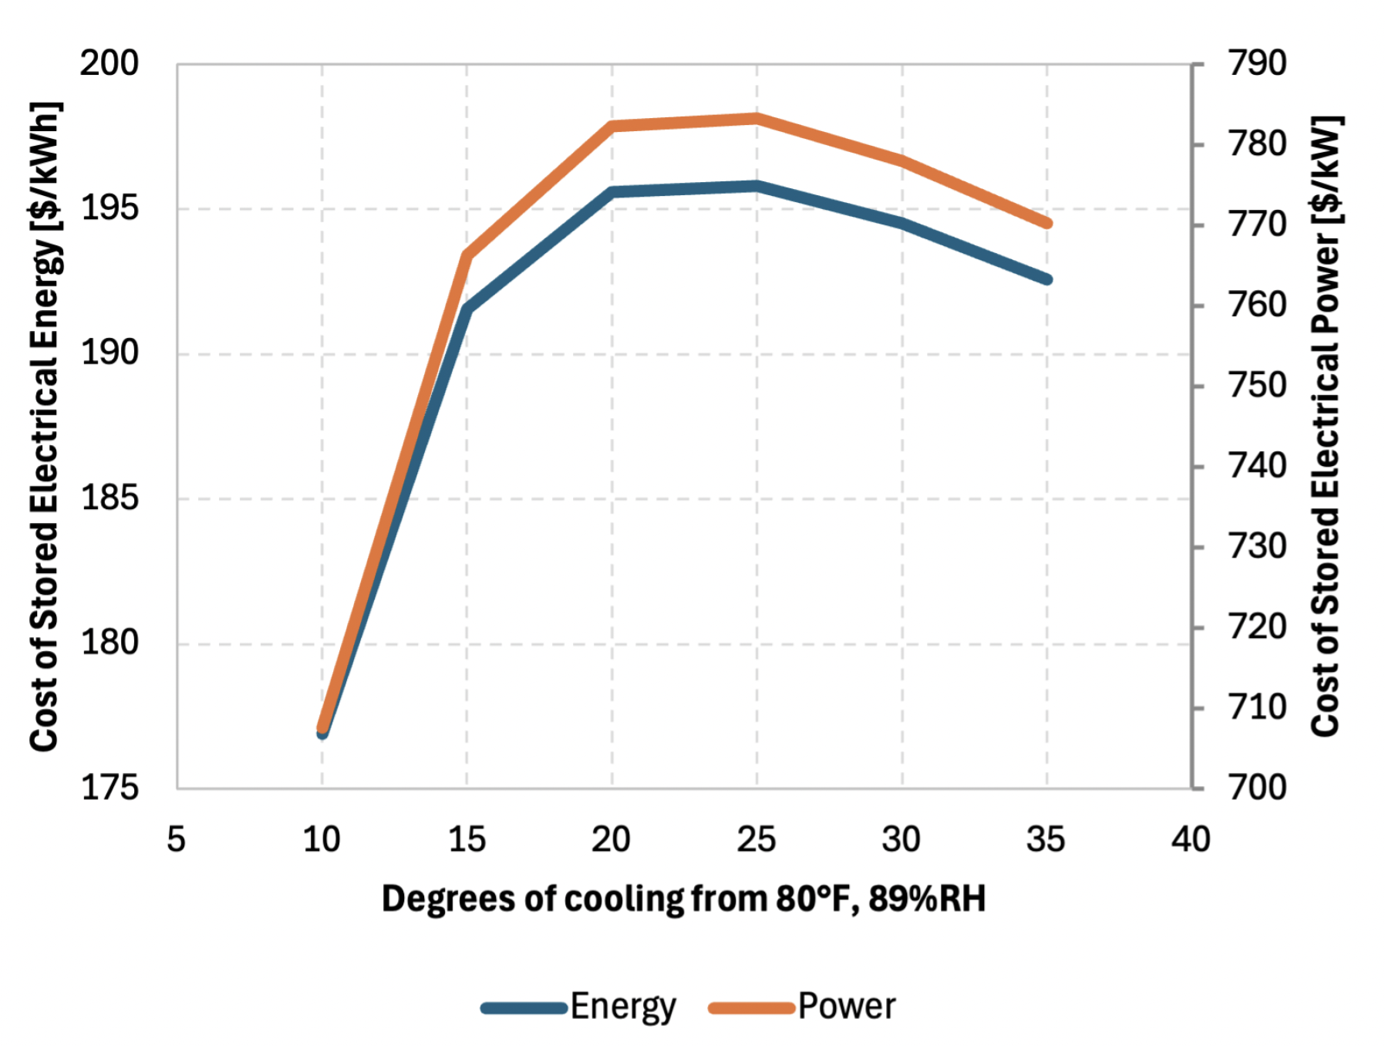
Cooling inlet air to moderately lower temperatures can appear attractive but may place the system in the least efficient thermodynamic regime.
Deeper cooling produces three important effects:
• Higher air density entering the compressor
• Greater turbine output and efficiency improvements
• Lower relative energy loss to moisture condensation
When these effects are combined with the capital cost advantages of thermal storage, deeper turbine inlet cooling becomes a compelling option for improving generation asset performance.
The physics is clear: colder inlet air delivers better turbine performance.

What This Means for Your Facility
Ice-based thermal energy storage systems can operate well below the inlet air conditions typically achieved by chilled water, enabling sustained deep cooling and unmatched turbine boosting.,,
Rebound’s AgileEnergy™ thermal energy system is designed to access this deeper cooling regime, storing cooling as ice and deploying it precisely during high ambient conditions. This allows operators to achieve lower inlet temperatures without the water consumption, cost, and operational limitations of traditional approaches.
The next step for operators is evaluating which systems can reliably deliver this level of cooling in real-world conditions—while maximizing performance, minimizing resource use, and aligning with evolving operational and regulatory constraints.

All modeling was validated against a Solar Turbines Titan 340 Turbine performance curve.
Humidity condition was chosen for Houston Texas worst case dew point condition.
Cost Projections for Utility-Scale Battery Storage: 2025 Update, NREL, 2025
Analysis was done using a 34MW Titan 340 turbine producing a 182MW-648MW / 6MWh-19MWh electrical energy storage system which could be compared to a battery.
Inlet Air Chillers for Gas Turbine Capacity Enhancement, 2012, EPRI
Evolution of Thermal Energy Storage for Cooling Applications, 2019, ASHRAE
An Evaluation of Thermal Energy Storage Options For Precooling Gas Turbine Air, 1992, PNL

