

AEX: The Most Cost Effective Ice Maker For Thermal Energy Storage Applications

Rebound Technologies
December 2023
For videos and more visit: www.rebound-tech.com/technology

SUMMARY
AEX™ is a new breakthrough ice banking product set to disrupt cooling across the industrial and commercial sectors. AEX uses a self-healing active surface chemistry to achieve a 5X improvement in cost/capacity, a 10X improvement in heat transfer, and a 2X improvement in efficiency.

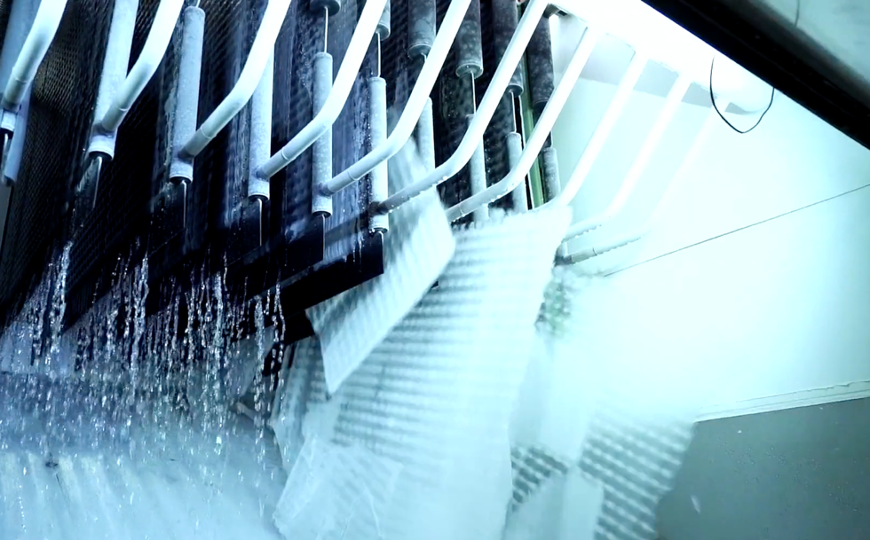
Figure 1: AEX during its harvest phase. The ice maker is significantly more productive than the current state of the art.

ICE MAKER PHYSICS
All ice makers, regardless of design, function under a fundamental constraint: as ice grows on any surface it inherently inhibits heat transfer through that surface. This constraint drives the cost, efficiency, and reliability of all modern ice makers. Despite a great need for energy storage and the significant advantages ice storage enjoys, these tradeoffs have not yet been effectively optimized. This is evident in the universal failure or commercial stagnation in the market development of ice-based energy storage efforts,,,.

REBOUND’S APPROACH
Rebound has developed a novel approach to ice making that charts a new course through these constraints to realize a machine capable of producing higher quality ice at 5X lower costs than traditional approaches. Importantly, this ice maker uses 100% off the shelf process equipment and can be produced at scale without massive investment in new product development or new manufacturing processes.
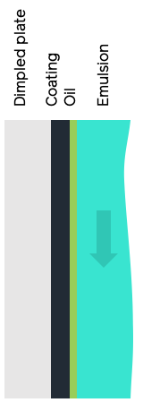 | 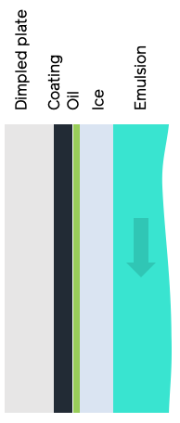 | 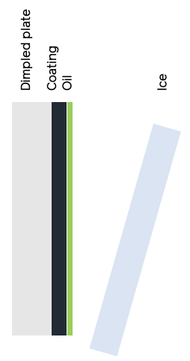
Step 1: Coating  An oil-water emulsion flows over a coated dimpled plate. The oleophilic coating draws oil out of the emulsion to form a self-healing submicron oil layer on the plate. | Step 2: Growth  Ice begins to grow on the plate trapping the oil between the ice and plate. Pure ice, free of oil, continues to form out of the emulsion. | Step 3: Harvest  The flow of emulsion is curtailed while refrigerant continues to cool the dimpled plate. The temperature drops, subcooling the ice and creating a thermal expansion driven strain between the ice and plate causing the ice to fall off.
Figure 2: the growth-harvest cycle of Rebound’s ice maker
Fundamentally, AEX is a plate ice maker which goes through a typical growth harvest cycle: ice grows on the cold plate then is harvested when it reaches a desired thickness. However, unlike a traditional plate ice maker, AEX harvests using subcooling instead of heating, which leads it to harvest significantly faster without any loses even when ice is grown in thin sheets. This is accomplished by paring a chemically matched plate coating and an oil dopant in the water that creates an ideal surface chemistry for ice making. Figure 2 shows the basic process.
By controlling surface chemistry with a thin liquid film (1um thickness) over a solid coating, a robust self-healing layer is created that dramatically improves the overall ice maker performance. This configuration leads to several key benefits of AEX over the state of the art:
- Thinner ice can be grown and harvested without loss.
- Subcooled 100% solid ice is produced.
- Harvest is rapid, leading to a 90% reduction is wasted time.
- Plate temperatures are (relatively) high, leading to higher efficiency.
- No mechanical harvesting techniques are required, the only moving part that is used is a mag-drive water pump.
- Off-the-shelf dimpled plates mean the ice maker is infinitely scalable today.
The system is ideal for large energy storage applications because it is highly scalable. Like traditional plate ice makers that sit over a large water/ice tank, the plates can be arranged above an emulsion tank where the movement of the water by a centrifugal pump creates the emulsion required for the plates. In this configuration a single tank of water can be slowly converted to ice to store cooling for HVAC applications, turbine inlet cooling, or other industrial processes that require intermittent high levels of cooling. This system has one moving part, a mag-drive centrifugal water pump.

Rebound has built multiple full-scale units, generated millions of pounds of ice, and stored that ice for days at a time. This body of work has demonstrated several key performance and reliability features of this technology for use in thermal storage markets:
- 100% dry subcooled ice production at -5°C and -10°C refrigerant temperature
- Self-healing active coating with infinite life
- Greater than 12 hours of continuous operation without defrost or plate heating of any kind
- Rapid ice harvesting of <1min without ice loss
- Ice storage in a simple fiberglass tank without re-solidification or “iceberging” for 1-5 days
- Powder coating robustness through thermal cycles, incidental mechanical contact, and >10k ice harvests.

Table 1 shows the significant improvement AEX represents over the state of the art. Of note, all these systems use nearly identical off-the-shelf components and manufacturing techniques. The only additional step required to manufacture an AEX is the powder coating of the plates prior to the system assembly. This step is accomplished by a mature coating process performed by many coaters across North America and adds <5% to the cost of the ice maker.

Table 1: Comparison of Rebound’s ice maker with a traditional thermally harvested plate and ice-on-coil ice maker
 | Typical Ice-On-Coil System | Typical Plate Ice Maker | AEX
Harvest method | direct flow | hot gas | subcooling
Ice Lost in harvest | 0% | 10-20% | 0%
Growth time [min] | multi-hour | >15 | 6
Harvest time [min] | multi-hour | 5 | 1
Ice Thickness [in] | >6in | >1/2” | <1/4”
Suction temp [°C/°F] | -30°C (-22°F) | -18°C (0°F) | -7°C (20°F)
Overall heat transfer [kW/m²-K] | 0.04 | 0.2 | 0.5
Levelized Capex [$/(lb/day)] | $50 | $20 | $5

CASE STUDY: DATACENTER ICE BANKING
Storing ice for facilities with large HVAC loads like datacenters has long been discussed and piloted, but never realized at scale. This failure is due to fundamental limitations of common ice-on-coil storage techniques. The thermodynamic limitations of these installations lead them to increase energy costs instead of decreasing them. Rebound’s ice maker represents a dramatically cheaper and more efficient option for this market that can operate within the thermodynamic limits of HVAC ice banking.

All ice makers must operate at a temperature below freezing while chillers used in HVAC applications like datacenters do not. Since the efficiency of any cooling cycle is a function of its cold-side temperature, an ice banking system in such an application needs to operate at a high temperature (-7°C for example). Ice-on-coil systems typically operate at low temperatures (-20°C for example) to reduce capex, but at these low temperatures their coefficient of performance (COP) is so low that the money they save by shifting power purchases is overwhelmed by the increase in overall energy purchases and they offer little or no net savings. When they are modified to operate at higher temperatures (-7°C for example) their capex explodes due to their internal temperature pinches and poor heat transfer characteristics. Here, we present a case study based on the datacenter summarized in Table 2.

Table 2: Datacenter specs and ice-maker agnostic ice system requirements
 | Facility Spec and Requirements
Location | SW USA
HVAC thermal load | 40MW_{thermal}
Peak period / Storage capacity | 6hr
Summer peak price | 12 ¢/kWh
Winter peak price | 8 ¢/kWh
Off-Peak price | 5 ¢/kWh
Summer peak demand charge | 10 $/kW
Winter peak demand charge | 5 $/kW
Facility area | 130,000ft²
Yard area | 80,000ft²
Ice bank water charge | 600,000 gal
Yard space / Facility space usage | 11% / 4%
IM COP / Facility chiller COP | 3.5 / 4.5
Annual energy savings from ice bank | $1,200,000

Figure 3 shows a top-down view of the facility described in the table above. The ice bank area is dominated by ice storage tanks. While buried tanks are possible in either ice-on-coil and Rebound ice maker-based systems, above ground cylindrical tanks are assumed with ice plates, air-cooled condensers, and refrigeration equipment located above each tank.

In this analysis a plate-based solution is assumed in both cases because hydraulically expanded plates represent the lowest cost externally accessible heat transfer surface today. Furthermore, both systems are sized to run at the same suction temperature of -7°C and produce the same amount of ice each day.

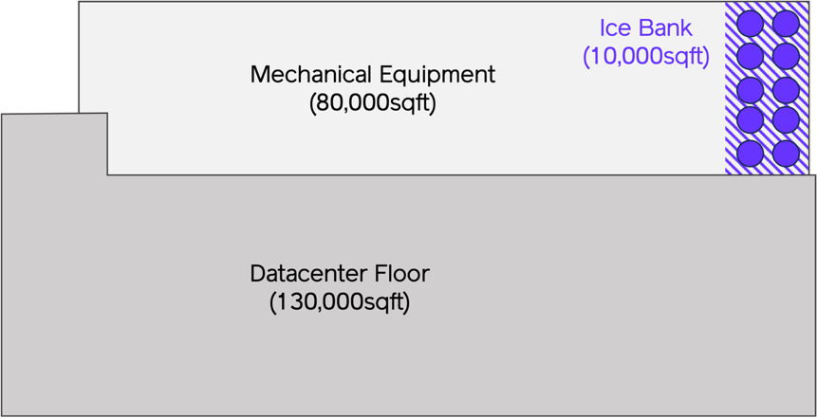

Figure 3: Top-down view of a datacenter with ice banking. Datacenter floor = space with actual server racks, Mechanical equipment = backup generators, chiller equipment, etc. Ice bank = space for ice tanks and ice making equipment.

Figure 4: Resistance to heat transfer experienced by an ice-on-coil storage system vs Rebound’s ice maker during the 18hr charge period for the identical amount of ice produced at the same temperature. This plot represents the resistance to heat transfer of the equipment, thus, low values are good.
Figure 4 shows the modeled heat transfer performance of the plate over the course of an 18hr charge. During this time the ice-on-coil system runs at an average of less than 4% of its potential ice making power rating where the Rebound ice maker runs at above 30% on average.
Table 3: Resulting economics of both an ice-on-coil and Rebound based ice storage system. Cost assumptions capture: additional cost of powder coating Rebound plates, additional cost of oil and oil-compatible tanks in Rebound ice making system.
 | Ice-On-Coil | Rebound Ice Maker
Levelized ice production rate | 3 kg/hr-m² | 36 kg/hr-m²
Required area | 35,000 m² | 3,200 m²
Peak surface area of produced ice | 35,000 m² | 580,000 m²
Cost of plates | $28,000,000 | $2,700,000
Cost of tanks | $660,000 | $1,200,000
Condensing unit | $3,000,000 | $3,000,000
BOS costs | $1,500,000 | $1,800,000
Total costs | $36,000,000 | $8,700,000
Chiller capex savings | $2,700,000 | $2,700,000
Utility Savings Payback | 30yr | 7yr
All In Payback | 27yr | 4yr

Table 3 shows the resulting economic performance of these two systems. While these systems are similar in design: no moving parts, no hot-gas ice harvesting, and use of low-cost hydraulically expanded plates, the economic performance is miles apart due to the fundamental heat transfer limitations of an ice-on-coil system. Some other benefits and details of AEX:

- It doesn’t use a glycol intermediary loop which increased performance, simplifies the system, and reduces capex.
- It doesn’t have submerged plates, making any maintenance significantly easier.
- It produces an ice pack in its tank with 17X as much surface area allowing chilled water to be produced without the added complexity of air bubbling required in ice-on-coil systems.
- When we include facility capex savings, ESG cost savings, and generator savings, paybacks for AEX technology drop to around 4yrs.

While AEX represents a phenomenal step forward in ice banking technology, it is also important to put that technology into the context of current incumbent chilled water efficiency gains and power usage effectiveness (PUE) improvements. Over the past 10 years, the development of massive hyperscale datacenters has led to significant reductions in energy use through increased efficiency. This has been accomplished by running facilities at higher air temperatures. This allows chilled water temperatures to also rise, leading to significantly higher chiller efficiencies and more house of “free cooling” per year. While this leads to a significant impact on energy cost, it comes at a high facility and development cost.
Figure 5 shows an example of the impact of integrating AEX at the same 40MW datacenter and the performance of a similarly IT load datacenter operating at a much higher air temperature in a hyperscale PUE setting. While the ice bank equipped datacenter consumes more power than either the average or low PUE case, its operating cost is the same as the low PUE case. This is because 70% of energy cost are incurred during peak rate periods and avoiding these can easily offset additional energy purchased during low cost. Furthermore, shifting purchases away from peak periods tends to optimize the use of free ambient cooling.
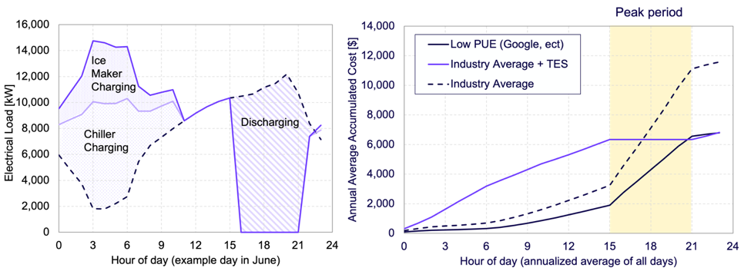
Figure 5: (left) example charging and discharging profile of a Average datacenter and one equipped with thermal energy storage (TES) without any other modifications. Ice making produces both ice maker and chiller electrical load. (right) Hourly average daily energy consumption (including free cooling) for all 3 cases showing how impactful avoiding peak rates can be.
This case study makes clear the essential point: up until now ice banking in a datacenter environment was nowhere near cost-effective. With a 5X faster ROI, the Rebound ice maker can change that and enable a path to lower operating costs that doesn’t require hyperscale level infrastructure investment. Now there is a path to viable economic return which in turn drives system development, capex improvement, performance optimization, and massive amounts of low-cost grid storage.

CURRENT SCALE AND FUTURE MARKETS
Rebound has built multiple full scale production ice makers using this patented technology. The design is agnostic to refrigerant and Rebound has, to date, run these ice makers using R134a and ammonia as a refrigerant. As currently configured, Rebound’s largest ice maker (shown in Figure 6) can make 60,000lb of ice a day and has, to date, produced over 4,000,000lbs of ice. There are no design constraints that prevent scaling up to >1M lb/day capacity.

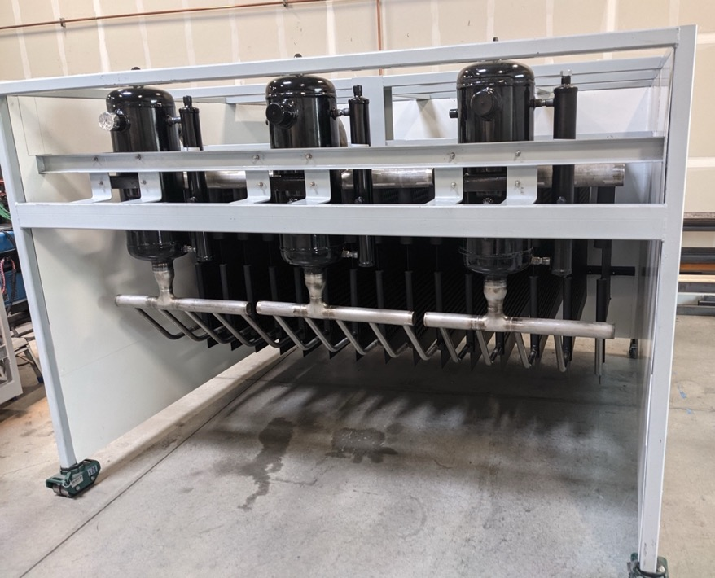
Figure 6: A 60,000lb/day ice making module ready for hookup to refrigerant feed.
AEX is commercially ready for deployment in many thermal storage cooling applications. Covered by 2 issued and multiple pending patents, this technology is ready to scale up to meet the demands of large thermal energy storage markets like turbine inlet cooling, datacenter cooling, and HVAC ice banking. Where other ice making systems have failed to deliver the cost, efficiency, and scalability that is required in these markets, AEX is unique in its simplicity and approach making accessing these markets a reality.

Ice energy files for bankruptcy: https://bit.ly/47XjfAV
BAC has moved away from their ice storage product: https://bit.ly/3v1UxAY
CALMAC sells to Trane after 70 years of tepid growth: https://bit.ly/3TtWDUm
Axiom Exergy Fails to commercialize ice storage and pivots to software only: https://bit.ly/3Ntkf7W

